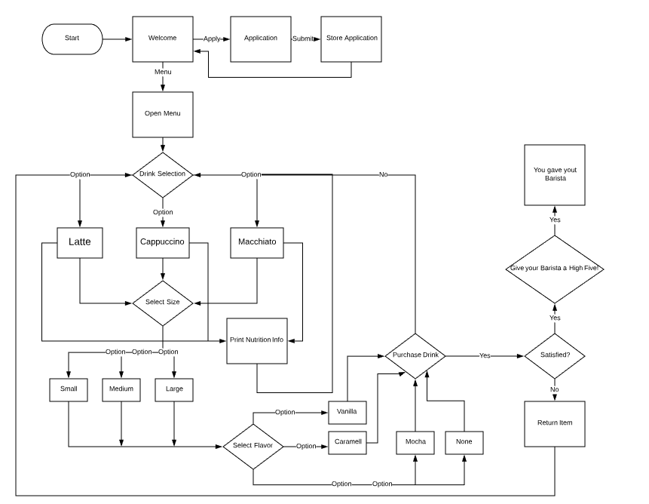

Class Drink Class Latte: public Drink

protected: public:

float price; //price Latte(string add, char size)

string add; //added flavor this->add = add;

char size; //size this->size = size;

public: this->price = 3.00 //base price

Drink() float price()

float price() //returns price dependent on size and flavor

Class Capp: public Drink

//Shares similar functionality as Latte

Class Macchi: public Drink

//Shares similar functionality as Latte

Class Employee

vector<string> barista; //setting names are Baristas to call on for welcome

bool hi5; //high five status

Class Customer

string name; //ask name for coffee order

bool hi5; //high five status